HILLY FIELDS FOOTBALL CLUB
SEASON 20: 1986-87
FIRST TEAM:
BECKENHAM LEAGUE:
P W D L F A Pts Pos
Division 1 14 4 2 8 18 43 10 6th
Beckenham League Cup 2 1 0 1 5 5
Beckenham Hospital Cup 1 0 0 1 2 3
Hither Green Hospital Cup 3 1 1 1 3 4
Peter Bowden Invitation 3 0 0 3 5 12
Friendly 5 0 2 3 8 26
TOTAL 28 6 5 17 41 93

Apps Gls Apps Gls
Charlie Benson 2 0 Dave Norman 2 1
Nigel Boyce 5 0 Gavin Phipps 13 1
Dean Chatfield 18 14 Tommy Salacuri 23 0
Mick Chatfield 20 0 Gavin Sellick 1 0
Mark Collins 3 1 Kevin Shearer 24 3
Steve Ford 16 4 Charlie Shoppee 19 0
Keith Foster 13 0 Mario Vaz 2 0
Len Franklin 8 0 Winston Vaz 1 0
Paul Hill 2 1 John Wood 25 3
Dennis Jarvis 1 0 Chris Yusuf 21 1
Dave Keay 18 1 Alan 1 0
Mike Kiely 8 0 Steve 1 0
Kevin McCormick 24 0 Dave 1 0
Adam Mosley 21 10 OG 1
Pat Mulligan 6 0

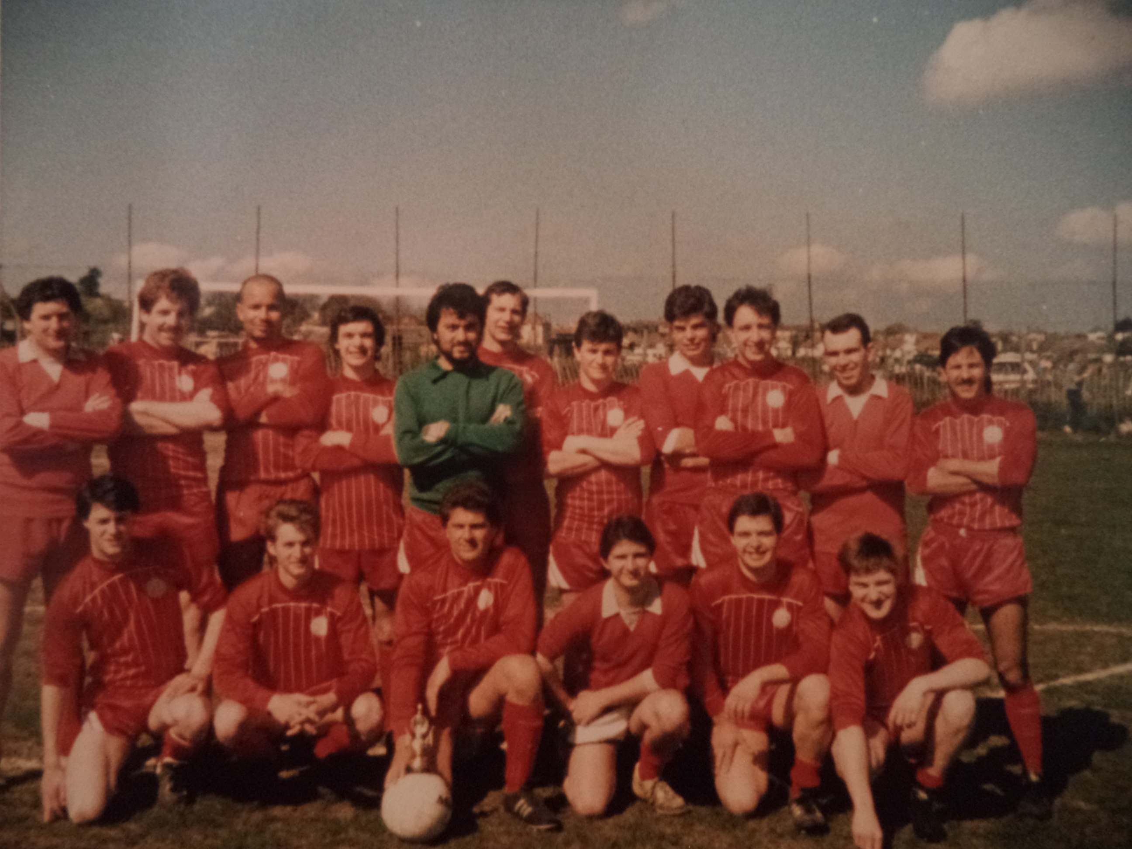
L-R Back: Len Franklin, Dave Keay, Chris Yusuf, Dean Chatfield, Tommy Salacuri, Keith Foster, Mick Chatfield, Mark Rumbelow, John Wood, ? , Charlie Shoppee, Adam Mosley, Steve Ford, Kevin Shearer, Tim Shawcross, ?, Tony Buckley

